Please calculate the PED of the below.

PED Formula | Percent Change Formula
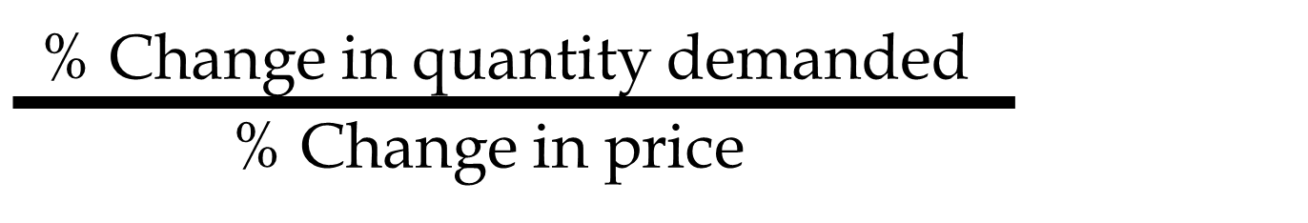 | 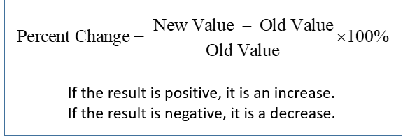

Example 1
When the price of Potato Chips increased from $20 to $22, the quantity of Potato Chips demanded decreased from 100 to 87.
What is the price elasticity of demand for Potato Chips?
Example 2
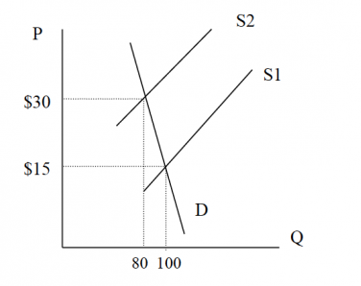

- What happens to the price?
- What is the percentage change in price?
- What happens to quantity ?
- What is the percentage change in quantity demanded?
- PED therefore is:

Example 3
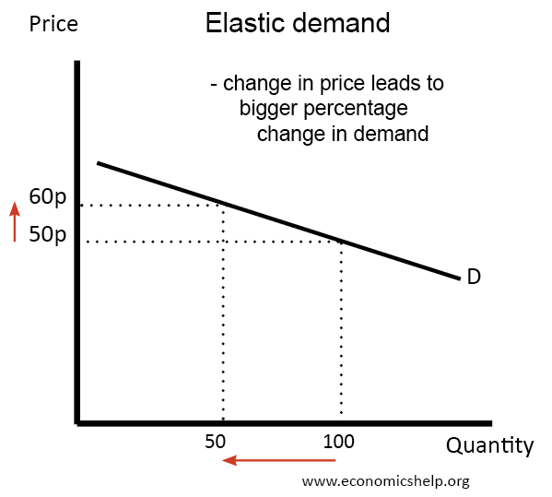

- What happens to the price?
- What is the percentage change in price?
- What happens to quantity ?
- What is the percentage change in quantity demanded?
- PED therefore is:

Example 4
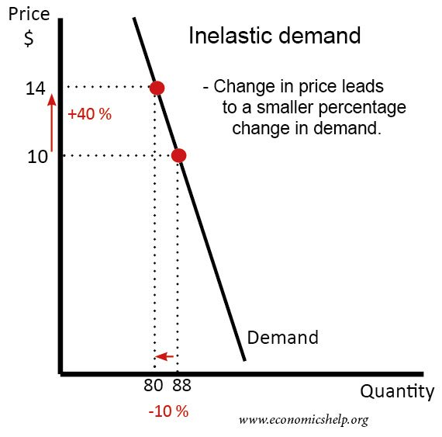
- What happens to the price?
- What is the percentage change in price?
- What happens to quantity ?
- What is the percentage change in quantity demanded?
- PED therefore is:

